Learning to Predict Problem Difficulty in Uncertain Reserve Selection

Bill Langford - Dec 12, 2022

Biodiversity reserve selection is a branch of systematic conservation planning concerned with optimally allocating limited conservation funds to maximally protect species of interest, e.g., through purchase of biodiversity reserves. Over the last 35 years, there have been hundreds, if not thousands, of academic papers on how to best do this using optimization methods such as mixed integer programming and simulated annealing.

Unfortunately, the claims made in this research almost universally ignore the fact that each reserve selection problem has a different relative difficulty as well as different types and amounts of input error/uncertainty. Testing of methods in this domain almost always consists of someone proposing a new method or problem definition and then applying it to a single "real-world" location of their choice, with unknown types and amounts of input error. While this would be reasonable for something like linear programming with correct input data, ecological data is always far from correct and generally of multiple types and unknown amounts. Moreover, there are no shared benchmark sets of problems, real or synthetic. Nearly every paper has a sample size of N=1 and almost no paper even uses the same dataset as another paper unless it's by the same author.

These are serious problems for two reasons. First, input uncertainty is large, spatially variable, and ubiquitous in ecological data so method assumptions are nearly always violated. Second, these methods are used in real-world conservation applications such as conservation planning for the entire state of Victoria or the entire nation of Madagascar. Errors in the outputs have real consequences for the extinction of hundreds of species, but the users of these methods have no way to know whether their particular problem is likely to be hard or easy for their chosen reserve selector, much less estimate the likely amount and kind of error the solution produced.

This summary looks at a sequence of 3 draft papers that borrow techniques from computational theory to build problems with known solutions, varying difficulty, and varying amounts and types of input uncertainty. The end goal is to begin to learn to predict how much error there is likely to be in the proposed solution to a single user's specific problem. Our issue is not with their being error in the solutions; the problem is difficult. Our issue is with not giving users any idea of whether the solution they're given is actually any good at all. Some problems are easy enough that the erroneous solution is not so bad that it should be rejected, but we claim that many solutions are likely to be wildly inaccurate and perhaps should not be used at all. Without a better understanding of these problems and their structures, the development of better methods can't progress.

After this introductory section, I’ve included a couple of plots from each draft to give you an idea of the kind of analysis and conclusions that they allow. Figure 2 is the most important plot in this document. Before going to those sections, I will add a couple of notes and informally state the optimization problem that we're trying to solve and evaluate under input uncertainty.

**Reserve selection problem formulation**

There are many different formulations of this problem, but the one we discuss here is arguably the simplest version:

* Given:
  + a set of species to protect
  + a set of planning units (e.g., property parcels or ecotype regions) representing the landscape of interest (e.g., the state of Victoria)
  + a target for each species (i.e., the minimum number of occurrences of that species required in the solution)
  + a cost for each planning unit
* Choose a set of planning units that meets or exceeds all species targets for the minimum total cost

In the work described here, all costs are identical (i.e., 1) and all targets are identical (i.e., 1 occurrence of each species). This makes the problem equivalent to the Minimum Set Cover problem in computational theory.

**Note: Error measures and problem difficulty**

When we refer to "problem difficulty", we're not talking about how long it takes to solve a problem or some measure of branching, etc. We're talking about measures of error in the output. This can be

* relative error in the solution cost with respect to the known optimal cost, or
* representation shortfall in the solution, i.e., the fraction of species who don't meet their target even though the optimizer thought they did.

Often we combine the two measures into a single root sum squared measure for simplified plotting.

We also examine a more normalized measure of error by looking at the output **error magnification**, i.e., the ratio of any output error amount to the input error amount. A magnification value of 1 is essentially a "garbage in, garbage out" view, which is especially relevant in ecology. In ecology, people often claim (with little evidence) that they have little input error so they can assume that their output error is probably not too bad. Figure 2 shows otherwise, with rays for different magnifications.

**Conventions in the plots**

* In all but Figure 1,
  + red dots are problems where the added uncertainty was dominated by False Positives (i.e., input data declared a species to be on a Planning Unit where it actually does not occur)
  + blue dots are dominated by False Negative errors (species that actually occur on a Planning Unit but are not reported there).
* In what follows, “cost error” does not refer to errors in the *input* costs, i.e., Planning Unit costs. It refers to output error in the reserve selector’s estimate of the optimal *total* solution cost, i.e., the total number of planning units required to meet all species targets.
* Results here are from 4 commonly used reserve selectors:
  + Gurobi (mixed integer programming),
  + Marxan (Simulated Annealing),
  + Marxan’s Summed Solution (ensemble voting), and
  + UR_Forward (a simple greedy “unprotected richness” heuristic)

# Paper 1 - Explanation of problem generator methods using solution planting

The first paper explains the method that I’ve borrowed and extended from Xu's model RB method for generating problems of varying difficulty in exploring the phase transition in difficulty of SAT problems. Xu's method has the advantages of i) being simple to program, ii) having a known (planted) optimal solution, and iii) theory behind its parameterization to enable the construction of problems with a wide range of difficulty based on their distance from the phase transition.

In addition to his SAT version where the theory is developed, he provided a translation of the method for Maximum Independent Set, which I've then mapped into Minimum Vertex Cover and from there into the simple reserve selection problem above. This is done by treating planning units as vertices and species as links, where the vertex at each end of a link has one occurrence of the species represented by the link. Solving the vertex cover problem then implies finding the minimum number of planning units to get one occurrence of each species.

Unfortunately, a reserve selection problem with exactly two occurrences of every species is far from realistic, so I have extended the method to allow the wrapping of arbitrary species rank abundance distributions around the original uniform distribution of two on each planning unit. In ecology, a rank abundance distribution takes the abundance of each species and sorts them in decreasing order from most abundant to least abundant. There are various ecological theories about what distributions occur in the world and why. One of the more popular theories suggests that real rank abundance distributions are lognormal and as an example, we use that distribution in this work. Regardless of that choice, the wrapping method developed here will allow nearly any distribution. Based on this extension of Xu's generator, we generate 3,000 ecologically plausible species distributions and associated reserve selection problems with known correct solutions, but no input uncertainties.

Figure 1 shows one of the figures from Paper 1 that helps explain the methods there. I don’t expect you to have any clue about how the methods work from reading just the figure caption here. The **main message** is only *to illustrate the kind of thing that’s in paper 1*.

Also note that the kind of graph used in paper 1 (and the diagram below) is not the bipartite graph used for prediction in paper 3, so don’t be confused by this graph not looking like a bipartite graph. This is a different kind of graph that serves a different purpose in generating the problems.

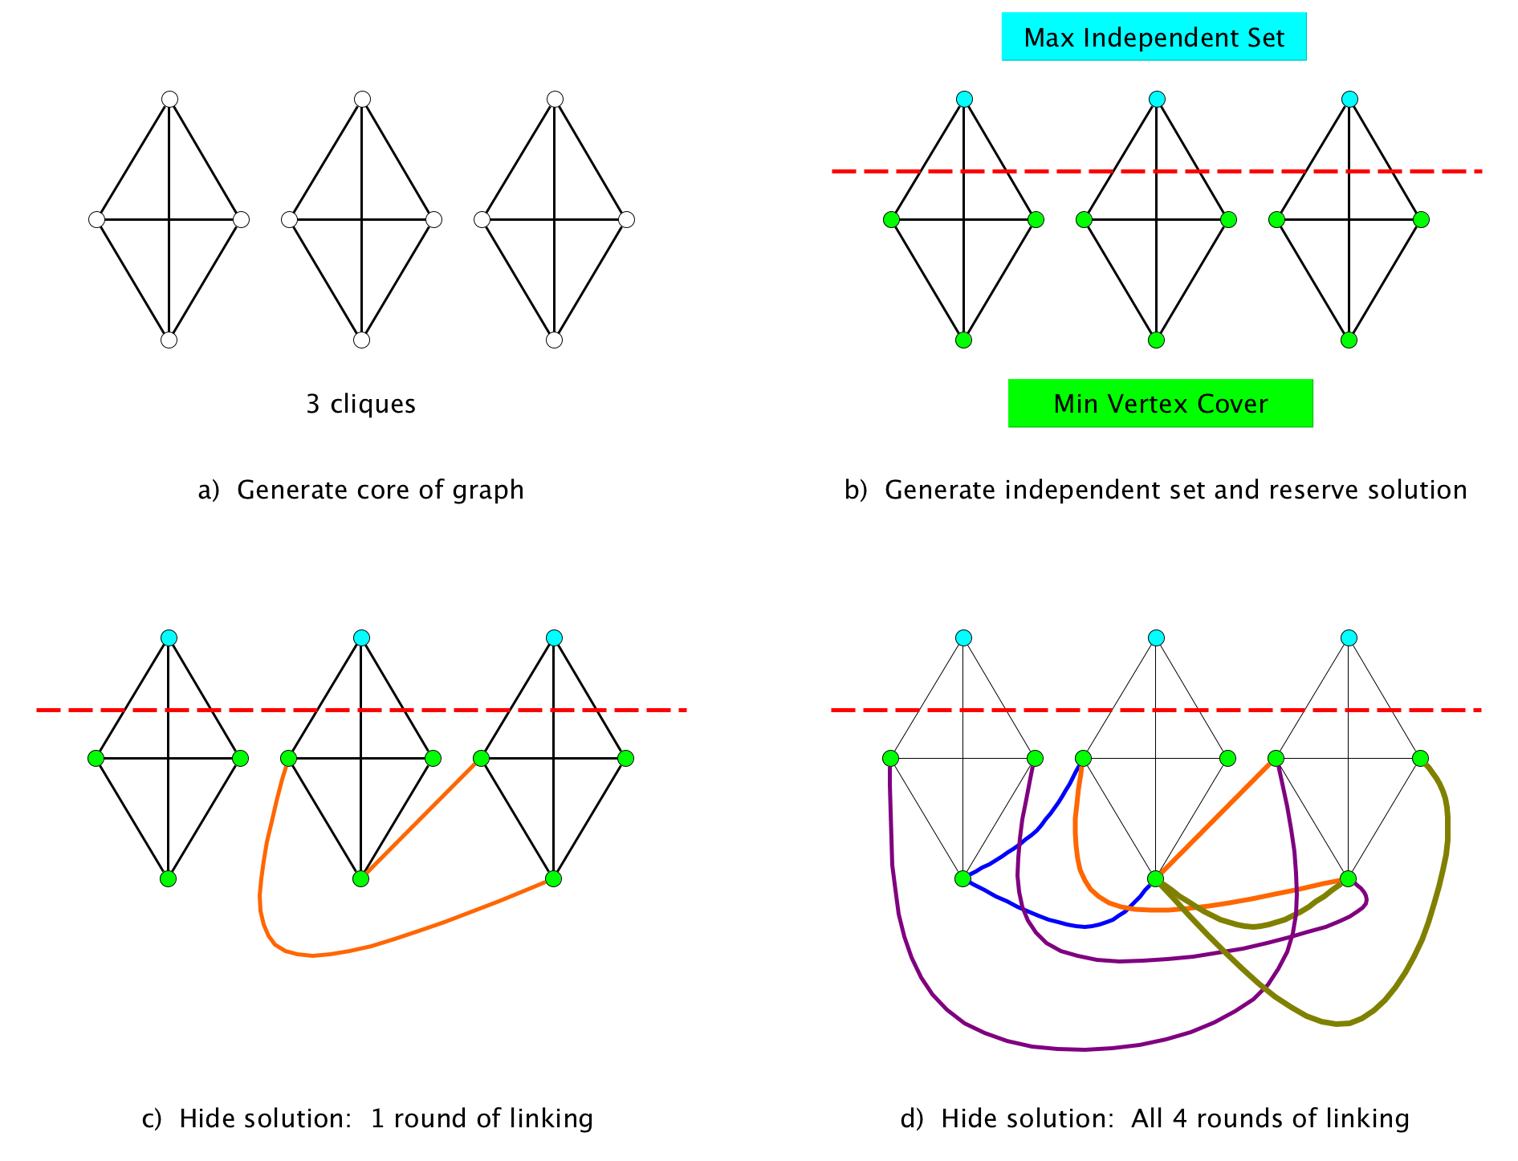

Figure 1: Diagram for example Base problem. Each subpane corresponds to a step in the problem generation process. Dashed line indicates separation between maximum independent set nodes and minimum vertex cover nodes, with the 3 nodes above the line constituting the maximum independent set of PUs and the 9 nodes below the line constituting the minimum vertex cover PUs, which is also an optimal reserve selection. Each link represents a species that occurs on the two connected PU nodes and nowhere else. Colors of links in c) and d) distinguish different rounds of linking.

# Paper 2 - Comparison of reserve selectors

The second paper takes the problems from the first paper, which already have varying difficulty but no input error, and creates 4 different variations of each problem by adding different kinds and amounts of input uncertainty to the species occurrence data. It then runs 4 reserve selectors on each of those 12,000 problems.

Figures 2 and 3 here show the results of those 48,000 runs. Figure 2 is the most important figure out of all the papers. The **main messages** are the huge *variation* in both performance and error magnification as well as the frequently *huge amount* of error in the solutions (up to and beyond 100% error) given that all input errors are less than 10% (even though we believe that nearly all real-world ecological problems will have far more than 10%).

One other message is that, for this data, the more exact the optimizer is on error-free input, the more error you get in the solution when there is input error (Figure 3).

Figure 2: .

Figure 2: .

* Each of the 12,000 points on each subplot represents one reserve selection problem.
* The **x axis** shows amount of input error on each problem, all of which are small, i.e., $≤$ 10%.
* The **y axis** shows the total output error in the reserve selector’s solution on the given problem. The axis is truncated at *only* 125% output error since there are fewer values $>$ 125%.
* The **3 rays** on the plot show the **error magnification (1x, 5x, 10x)**. The 1x ray at the bottom is input error equals output error. The middle ray is output error equals 5 times input error and the top is 10 times input error. Note that many values are even above 10x.
* The **median magnification** for each method isn’t shown but each is ~**5x**, so **at least half of all problems had $>$ 5 times as much output error as input error!** Mean values are even larger.
* You can also see from the plot that users would be **unable to predict the amount of output error** on any given problem even if they were able to know the amount of input error, i.e., you can find almost any amount of output error at almost any amount of input error.

Figure 3 below, breaks down the 2 types of output error that go into the total output error for each point shown in Figure 2, but Figure 3 differs in not displaying input error amounts. The **main message** is the very *different types of risk* when *input* errors are dominated by False Negatives vs. dominated by False Positives (e.g., from species distribution models). In particular, FPs can give big species representation shortfalls, which can have much more serious conservation consequences than the simple overspending on reserve costs that result from FNs. With FPs you're not protecting species that you that you thought you had protected. Unfortunately, FPs are also far more common in the input than FNs due to the use of species distribution models as inputs to reserve selection.

Figure 3: 

Figure 3: (explanation on next page)

* **Representation shortfall** on the **x axis** shows the percent of species in the given problem that failed to meet their target.
* **Solution cost error** on the **y axis** shows percentage error the reserve selector’s solution has with respect to the known true optimal solution cost from the correct input data.
  + Negative values mean that the reserve selector has underestimated the optimal cost, so it can’t go lower than -100%.
  + Overestimation can be unbounded but I’ve truncated positive y values at 125% error since there aren’t as many points beyond that (though the maximum is over 500%).
* The **tiny box at the origin is 10%** on each side. If everything was well-behaved and all output errors were less than or equal to the largest tested input error of 10%, they would fall in that box.
* The **larger box in the lower right shows the hardest problems**, i.e, all problems where both representation shortfall AND solution cost error are greater than 50%. About 5% of all problems fall in this box.
* **Total output error** in Figure 2 is the **vector magnitude** of corresponding point in Figure 3.

# Paper 3 - Learning to predict single problem output error from problem structure

Given the huge variation in problem difficulty and input uncertainty, knowing the average output error across all problems has little utility for a single, specific conservation decision. Consequently, the third paper looks at whether it’s possible to predict how much error a given reserve selector is likely to have on *the user’s own problem*. In real problems, we can’t know things like the true amount of input error or the correct solution, so we need performance predictors that can be measured on the problem as given to us with all its erroneous inputs. Problem size is one family of knowable predictor, but Figure 4 shows that it’s a poor predictor.

Another lens is to look at measures of problem complexity, so I converted each problem from a list of species and planning units into a bipartite graph and measured various attributes of that graph to use as predictors. I then fit models to predict what the total output error would be *on a given problem* using different kinds of *knowable* predictors (examples are in Figures 4 and 5). The bipartite measures did surprisingly well and much better than any of the other input variables.

**Figures 4 and 5** compare results of predicting individual problem output error using problem size vs. bipartite graph measures. The **main messages** are that problem size alone is a poor predictor but it’s possible to get a surprisingly reasonable predictor from the graph measures even without any knowledge of input error.

Note that all model predictions used in paper 3 are simple linear models trained on a training set of 3,000 problems and evaluated on a separate test set of 3,000 different problems. More complex models such as random forests had nearly identical behavior. I still have another 6,000 problems that I have kept in reserve for final evaluation.

Figure 4: Results of fitting solution cost error using just PROBLEM SIZE variables.

Figure 4: Results of predicting solution cost error using just PROBLEM SIZE variables (e.g., number of planning units and number of species).

**Figure 4 shows results of learning a model to predict total output error for a given reserve selector and problem based on size of the problem** (number of species, etc).

* The **x-axis** is the total output error value predicted for a given problem by the learned model.
* The **y-axis** is the true amount of total output error for the given reserve selector on the given problem.
* The **diagonal line** shows the desired outcome of predicted = true.
* I think that many people’s intuition is that as the problem gets bigger, it gets harder. However, as you can see in Figure 4, **size matters some, but not much**.

Figure 5: Results of fitting solution cost error using just BIPARTITE GRAPH measures.

Figure 5: Results of fitting solution cost error using just BIPARTITE GRAPH measures.

**Figure 5 shows an alternative, where I mapped each problem as a bipartite graph** with planning units as one type of node and species as the other type and then ran a bunch of bipartite graph measures over that graph. I then learned a model using some of those measures as the independent variables.

* This model **reduced the rmse by 2/3** for the 3 more exact reserve selectors compared to the values when using problem size.
  + Interestingly, Marxan’s **summed solution behavior is much less predictable** with either set of input variables.
* I’ve also fit a bunch of **other models using combinations of problem size and bipartite measures**, as well as things that you can’t actually know, such as the **amount of input error**.
  + Nothing helps more than a hundredth or two in the rmse or the adjusted $R^{2}$. The **bipartite measures capture almost all of the predictive power**.
  + Also note that the rmse and adjusted $R^{2}$ values are computed on a separate 2,000 problem test set, not the 2,000 problem training set (where the scores were higher). I still have another 8,000 problems set aside to use in the final paper that I haven’t looked at other than the summary statistics and plotting shown in paper 2. I haven’t used them at all for training or testing or feature selection for any predictive models.
* While even the bipartite model is far from perfect, it does show that there are different, structural ways of looking at characteristics of problems that help you **predict how much you should trust a given reserve selector’s solution**. This is something that I think managers would benefit from knowing and researchers are not addressing. Problem difficulty doesn’t seem to be on anyone’s radar at all and the comparisons in paper 2 show that it may be quite important.

# Web interface to data

All of the data in these papers comes from a single large set of experiments that took 5 or 6 months to run on 40 CPUs. What’s in the papers can only be the tip of the iceberg of possible analyses. Rather than writing a bunch of different appendices exploring different analysis choices, I’ve built a web interface to the data in Paper 2. It allows readers and reviewers to explore different choices using push button selections in the interface. The link is below. Since the data is big and the web server is free, it’s a little slow to load, but I think it will help support the papers.

<https://langfob.shinyapps.io/shinyServerUploadTest/>